How to connect the MS ACESS Database :

First step:

C: drive🡪java🡪jdk🡪jre🡪lib🡪ext🡪paste your jar files here.

We have to download the jar files from internet and we have to paste in the given path that I given in the below image.

Note: for to download the jar files I gave the link in last.

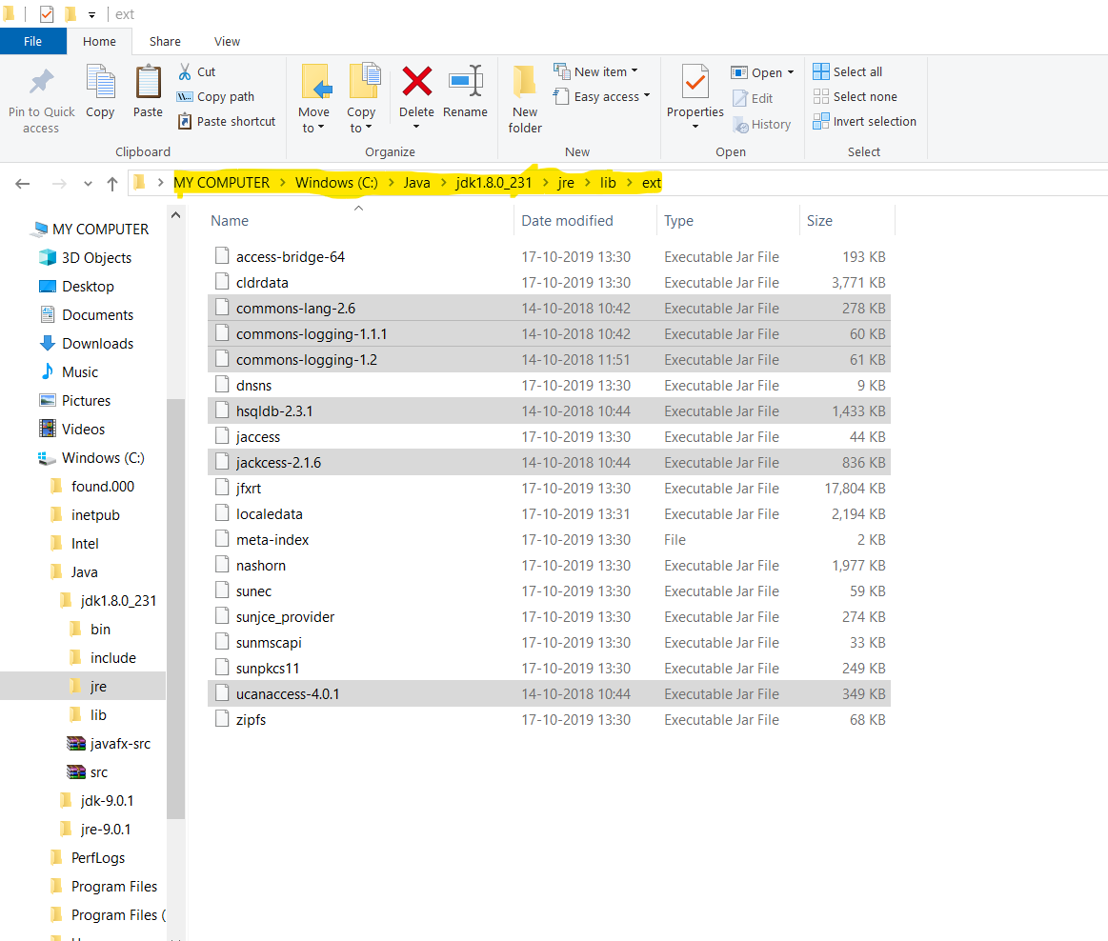

Second step:

After completing this work we have to connect manually

Administrative tools🡪ODBC DATA SOURCE 32 bit🡪dBASE files🡪 click add🡪Select the driver (“.mdb”, “.accdb”)🡪click select 🡪select you bin file🡪select the database file🡪Click ok🡪Data source tab enter your database file name without entering .accdb🡪 click ok🡪finally give ok..

In below I gave the Images for reference..

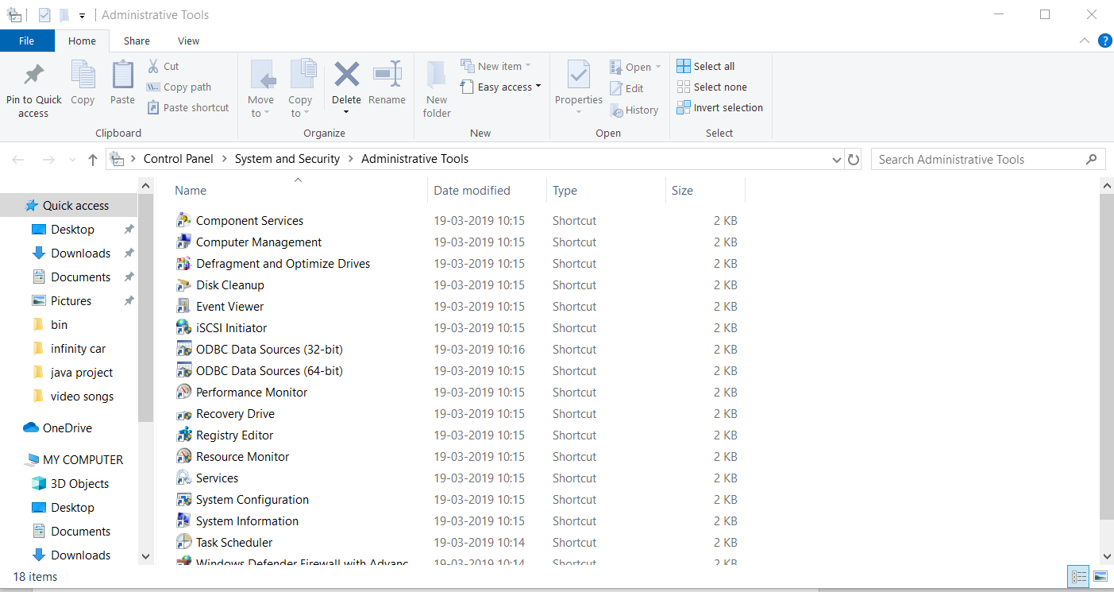

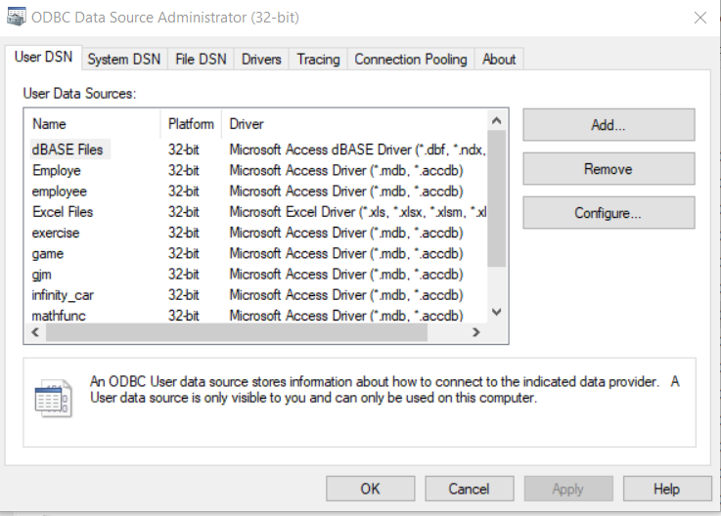

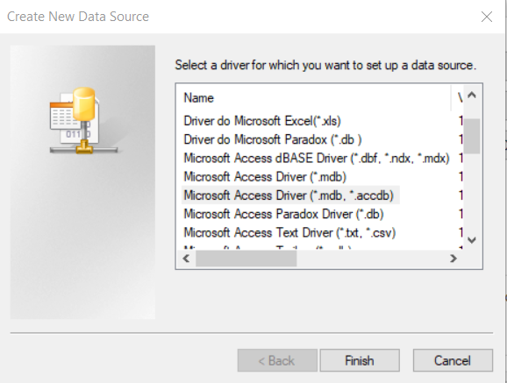

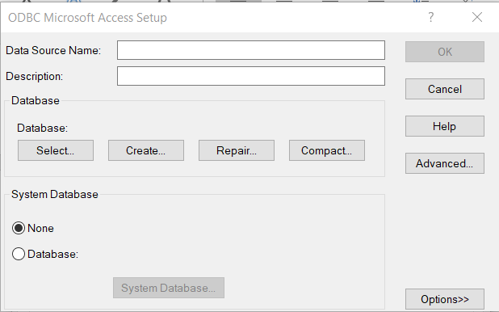

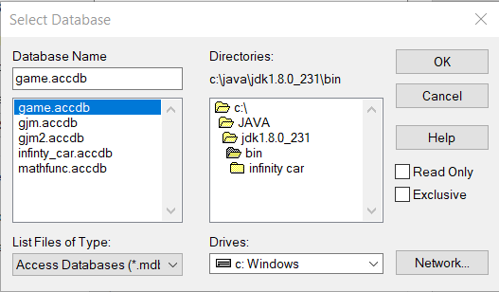

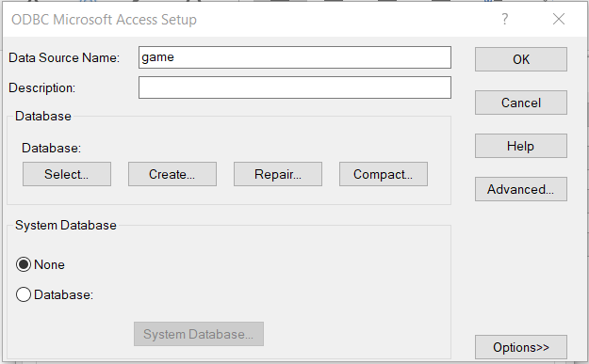

Jar files link:

<https://jar-download.com/?search_box=commons-lang-2.6>

<https://jar-download.com/artifacts/org.ow2.util.bundles/commons-logging-1.1.1>

<https://jar-download.com/artifacts/commons-logging/commons-logging/1.2/source-code>

<https://jar-download.com/artifacts/com.healthmarketscience.jackcess/jackcess/2.1.6/source-code>

<https://jar-download.com/artifacts/net.sf.ucanaccess/ucanaccess/4.0.1/source-code>

<https://jar-download.com/artifacts/org.hsqldb/hsqldb/2.3.1/source-code>